Software Requirements Specification

For

Anti.Paretic

Version 1.0 approved

Prepared by Nilasha Mondal (201014114)

Mahfuja Akter Shifa (201014001)

Sakib Ahmed Pathan Taif (192014045)

*CSE 438 Section- 1*

27/10/2023

Table of Contents

Table of Contents............................................................................... ii

Revision History................................................................................. ii

1. Introduction.................................................................................. 1

1.1 Purpose..................................................................................... 1

1.2 Intended Audience and Reading Suggestions.......................... 1

1.3 Product Scope........................................................................... 1

2. Overall Description...................................................................... 2

2.1 Product Perspective.................................................................. 2

2.2 Product Features....................................................................... 3

2.3 Operating Environment................................................................. 3

2.4 Design and Implementation Constraints....................................... 4

2.5 User Documentation..................................................................... 4

2.6 Assumptions and Dependencies.................................................. 4

3. External Interface Requirements.................................................... 4

3.1 User Interfaces............................................................................. 4

3.2 Hardware Interfaces..................................................................... 5

3.3 Software Interfaces...................................................................... 5

3.4 Communications Interfaces......................................................... 5

4. System Features............................................................................ 6

4.1 Prescription System..................................................................... 6

4.2 Appointments……........................................................................ 7

4.3 Progress Chart............................................................................. 7

4.4 QR Code...................................................................................... 7

4.5 Sign-up/Login……........................................................................ 8

4.6 Doctor’s Consultation History....................................................... 8

4.7 FAQ……………............................................................................ 8

5. Other Nonfunctional Requirements................................................ 9

5.1 Performance Requirements......................................................... 9

5.2 Security Requirements................................................................ 9

5.3 Security Requirements................................................................ 9

5.4 Software Quality Attributes.......................................................... 9

6. Other Requirements...................................................................... 10

Appendix A: Glossary.......................................................................... 10

Appendix B: Analysis Models............................................................... 10

Appendix C: To Be Determined List...................................................... 10

Revision History

| **Name** | **Date** | **Reason For Changes** | **Version** |
| --- | --- | --- | --- |
| Sakib Ahmed Pathan Taif, Nilasha Mondal & Mahfuja Akter Shifa | 19/10/2023 | Start | 1.0 |
| Sakib Ahmed Pathan Taif, Nilasha Mondal & Mahfuja Akter Shifa | 22/10/2023 | Brainstorming and reaching the conclusion on what the project will be. Writing process started. | 1.0 |
| S3akib Ahmed Pathan Taif, Nilasha Mondal & Mahfuja Akter Shifa | 25/10/2023 | Overall describing of the audience, functionality of the App and characteristics of the App discussed. | 1.0 |
| Sakib Ahmed Pathan Taif, Nilasha Mondal & Mahfuja Akter Shifa | 27/10/2023 | Made the overall SRS report and stated the TBD terms. | 1.0 |

# 

# 

# **1.** **Introduction**

## **1.1** **Purpose**

Our application’s name is iSigh.It is an application which we are intending to aid patients suffering from trauma like road accidents, or who have had a sort of paralysis to get to a better understanding of their condition without being daunted. We are trying to raise awareness in patients that they will get better soon and if they are facing a dilemma, they will get some closure without thinking against professionalism. Overall, we are trying to make subtle ways to make people understand that their situation, for healing is a process that doctors cannot explain vividly without raising a dilemma within itself. Doctors most likely will not be using the application but their scribe or nurse might get a digital signature, if needed, on a digital prescription list.

## **1.2** **Intended Audience and Reading Suggestions**

1. Development Team.
2. Project Stakeholders.
3. Designers and UI/UX Professionals.
4. Testing Teams.
5. Documentation Team.
6. Business Analysts.
7. Academic or Research Audience.
8. Potential Clients or Partners.

## **1.3** **Product Scope**

The application is targeted to answer some of the tough to understand bases of treatment that cannot be disclosed easily. It is meant to get across empathy for the patient’s understanding, their family, friends and also the personnel involved with the treatment who would not know how to actually respond when they see a figure written on paper. The goal though is to make a full reference prescription list, it could be from multiple doctors, organize appointments, organize time for medication and contacting the doctor to book an appointment when the date is nearing for a visit to the hospital or home visit by the doctor. At a likely testing phase, we might ask hospital organizations to sponsor us or buy the product once it’s ready. If not, we would go for crowdfunding.

# **2.** **Overall Description**

## **2.1** **Product Perspective**

Our application has the potential to be a new product. There are some applications that are close to our product, but are for motivation. Our application is more directed towards knowledge delivering or confusion resolving matters. It is simple because people who want to know can briefly go over the FAQ section and if they are wondering how far along a phase of the therapy is going, we will use a pie-chart to give visual aid for the people to see the progress. Our belief is that transparent knowledge should not be feared to jeopardize someone but at the same time make it known that a 5% progress on someone’s recovery may take 2 weeks, however at the same time a 30% recovery can take a day.

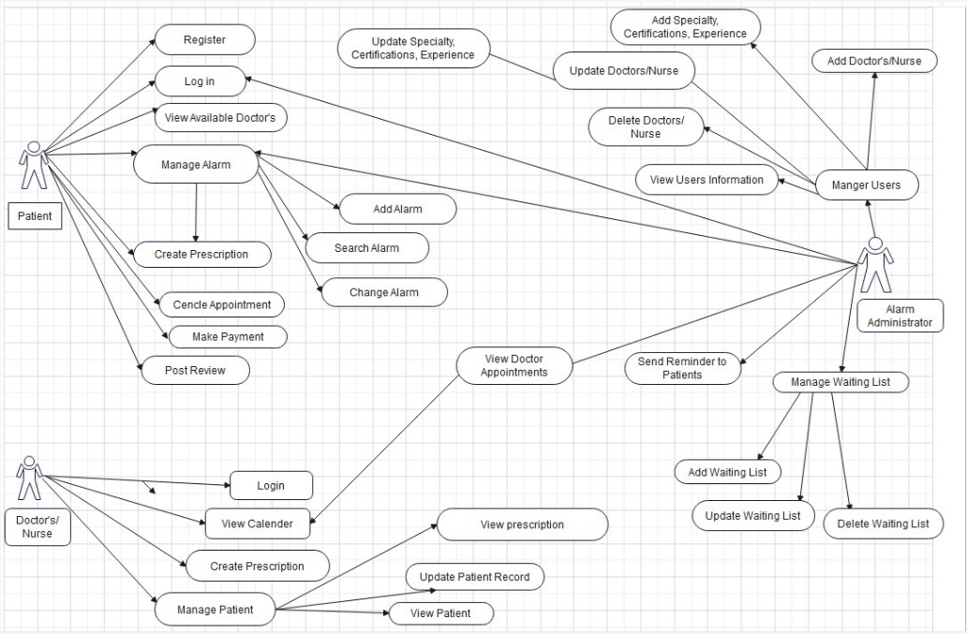

## **2.2** **Product Features**

The product features a Home page with 5 major options. It has a login and sign up, though the application is mostly for use offline. Also we are going to try putting a ‘Switch Account’ feature so that people can track multiple people’s medical history.

For patient:

1. A prescription system and its history.
2. Appointments to come and book an appointment.
3. Seeing progress, by pie-chart, and some discussion.
4. A QR code and/or scanner to synchronize information from the doctor to patient.

For doctor:

1. An access to a server that holds the notes of the doctors’ medication and consulting history.
2. Though constrained to our knowledge, of when to consider someone healthy enough, a way to get clearance that our current therapy objective has been met. Suppose a course of antibiotics is the therapy right now. If the patient shows signs of benefiting from the therapy, he’ll be acknowledged in the pie-chart.
3. A QR code and/or scanner which will synchronize when the next appointment should be on, for the patient to call and book the appointment or house visit depending on the doctor’s perspective.

For someone other than the patient, they will be able to synchronize someone’s medical information with their device which is the last major option. We may later change this feature because they can login to the patient’s account but instead we will try a ‘Switch Account’ system instead if need be to look after multiple patients at the same time. Moreover, there should be a ‘Remove Account’ feature as well that needs password authentication that comes on that page.

## **2.3** **Operating Environment**

The application is targeted towards Android and iOS. There should be a server and internet connection is required. It will have a subtle but optimized homepage but will be a rather small and convenient application. The application, because it is not a heavy duty or use software, should run on any smartphone without being resource intensive, for example, power or storage intensive. There will only be one background noise feature which is to prompt to check for an update on the patient, or doctor’s server for change. The other prompt is usually given by the PlayStore as a new version comes out.

## **2.4** **Design and Implementation Constraints**

Subject to change once we start and progress through the project.

## **2.5** **User Documentation**

Subject to after a valid prototype has been achieved. The application is simple. It has alarm-clock features, a calendar and a way to synchronize and get their prescription signed. We could give a YouTube video link to aid those who want a detailed understanding of the application.

## **2.6** **Assumptions and Dependencies**

<List any assumed factors (as opposed to known facts) that could affect the requirements stated in the SRS. These could include third-party or commercial components that you plan to use, issues around the development or operating environment, or constraints. The project could be affected if these assumptions are incorrect, are not shared, or change. Also identify any dependencies the project has on external factors, such as software components that you intend to reuse from another project, unless they are already documented elsewhere (for example, in the vision and scope document or the project plan).>

# **3.** **External Interface Requirements**

## **3.1** **User Interfaces**

1. Sign-up/ Login page.
   * Phone Number, Password and OTP verification
2. Main Dashboard.
   * Access Prescription, Upcoming Appointments or Visit, QR Code, Progress made in phases, FAQ and Log out.
3. Prescription management.
   * Add medicine details or picture of prescription and alarm for when it is time for medication.
4. Appointment dates Calendar.
   * View upcoming appointments and past details with an alarm feature for reminding of the visit.
5. QR code Synchronization.
   * To sync data with your doctor or someone related to you.
6. Doctor’s Consultation History.
   * Check notes for past visits.
7. Progress made pie-chart.
   * A way to see if you got stuck or gain determination but this part is not for disclosure but for empathy.
8. FAQ
   * It gives suggestions for knowing what terms mean, not how to tackle the challenge. That advice should come from the doctor. However, if the matter is of diet plans, sleep, distress, rest or bad habits, it will clarify the matter.

## **3.2** **Hardware Interfaces**

1. Camera to scan QR code.
2. Authentication via a kind of password.

## **3.3** **Software Interfaces**

1. Database management.
   * To store data securely on the cloud server.
2. Synchronization logic.
   * To update your data across devices.
3. User-Doctor profiles.
   * To keep track of your medical history and doctor’s details.

## **3.4** **Communications Interfaces**

1. SMS and Push Notification
   * For OTP when needed, alerting you of taking medication and appointments.
2. API integration
   * For connecting your application with servers and other services.
3. Offline mode Handling
   * To save your actions if you’re offline and to update them back when you’re online.

# **4.** **System Features**

## **4.1** **Prescription System**

4.1.1 Description and Priority

Priority is to update the prescription, dosage over time and set up alarms.

4.1.2 Stimulus/Response Sequences

Patient turns off or snoozes the alarm. The app gets updated when you’re back online.

4.1.3 Functional Requirements

TBD.

## **4.2** **Appointments**

#### 4.2.1 Description and Priority

Priority is to notify the patient when it’s nearing the time to schedule an appointment.

#### 4.2.2 Stimulus/Response Sequences

Patient turns off or snoozes the alarm and then schedules an appointment.

#### 4.2.3 Functional Requirements

TBD.

## **4.3 Progress Chart**

#### 4.3.1 Description and Priority

A pie-chart that completes a chunk at a time indicating percentage of the therapy process. Our therapy is for paralysis, so it’ll start with moving the head assisted. Then we start assisting movement in limbs. These alone will take 30% of the therapy process. Then we will move onto a daily range of motion and so on.

#### 4.3.2 Stimulus/Response Sequences

The doctor or nurse will assist until the patient is able to overcome these steps. When the patient seems to be able to do this without assistance, they can check these steps off the pie-chart on the app which will indicate recovery.

#### 4.3.3 Functional Requirements

TBD.

## **4.4 QR Code**

#### 4.4.1 Description and Priority

It will have the option to manually trigger synchronization of a patient's prescription or process along the therapy.

#### 4.4.2 Stimulus/Response Sequences

It will prompt that ‘The process has been completed.’ when the doctor has registered to the cloud. Once the patient has come back online, his application will sync to the cloud indicating medicine dosage time and prompt an alarm.

#### 4.4.3 Functional Requirements

TBD.

## **4.5 Sign-up/Login**

#### 4.5.1 Description and Priority

A basic sign-up with a password to create an account, if possible using cellphone number to send and verify using OTP.

#### 4.5.2 Stimulus/Response Sequences

Once OTP is verified, the user should stay logged in.

#### 4.5.3 Functional Requirements

TBD.

## **4.6 Doctor’s Consultation History**

#### 4.6.1 Description and Priority

The doctor sees his past consultation’s notes and test results.

#### 4.6.2 Stimulus/Response Sequences

The doctor consults the patient on how he is progressing and tries to cure him.

#### 4.6.3 Functional Requirements

TBD.

## **4.7 FAQ**

#### 4.7.1 Description and Priority

Notes with empathy on what type of injury causes what problem to arise. For example a bike accident may cause loss in feeling in legs for months which could be from nerve damage. Other problems like strokes may be from chronic illness.

#### 4.7.2 Stimulus/Response Sequences

The FAQ should be emphasizing on empathy, hope and dreaming to be better. For example, to move muscles again, first we’d need assisted movement. When the patient has the ability to start movement there, we’d put that FAQ part to saying that any spacious feeling in the arms or legs are no longer to be feared, and he/she should try and do these movements themselves and maybe tell him to try a bigger range of motion.

#### 4.7.3 Functional Requirements

TBD.

# **5.** **Other Nonfunctional Requirements**

## **5.1** **Performance Requirements**

All data should be readily available on the application because it should not need the internet to connect to the server very often. The prescription information should synchronize and the time to book the next appointment is to be dated. All other features are quite in fact offline, like the alarm on when to take medication.

## **5.2** **Safety Requirements**

Login needs a password to access but we would like the application to be always logged in so the system will prompt a password dialogue box when someone wants to logout, login or ‘Remove Account’.

## **5.3** **Security Requirements**

The patient needs to login by identifying as himself/herself on the phone.

## **5.4** **Software Quality Attributes**

If we get a few good alarm sounds, the product should stand out and be resourceful to get people to use it as available software. The FAQ section needs work for correctness, flexibility, interoperability, reliability, robustness, and verifiableness. On another front, the pie-chart which we will be featuring as one of the main functions needs to be reliable, so we will be working with 3-4 types of rehabilitation for now to get best results.

# 

# **6.** **Other Requirements**

Database requirements were not discussed but there should be enough space for 100 patients’ records and 20 doctors’ records to begin. We would need legal and political permission to have people try out the app, not to mention have it verified by Google PlayStore to be trusted enough.

**Appendix A: Glossary**

Spacious: an empty feeling where there used to be familiar movement.

**Appendix B: Analysis Models**

Use-Case diagram on page 2.

Appendix C: To Be Determined List

4.1.3, 4.2.3, 4.3.3, 4.4.3, 4.5.3, 4.6.3 and 4.7.3.